In the WINCHESTER CONSISTORY COURT

Re ALL SAINTS' CHURCH, HOUGHTON

JUDGMENT

A. Introduction.

1. By a Petition dated the 29th September 2013 the Rector and Churchwardens of All Saints' Church, Houghton, in Hampshire request permission to sell at auction (i) a painting believed to be of the "school of Albani" and (ii) the painting's carved wooden frame. All Saints' Church ("the Church") is a listed building (Grade II*) dating back to mediaeval times. Having lived for many years within a few miles of Houghton, I know the Church well. It is a delightful small village church characteristic of the chalk downland areas of Hampshire and surrounding counties. The village itself straggles down the west bank of the River Test south of Stockbridge.
2. In August 1921 a Mr Russell Smith offered the painting to the Parochial Church Council ("the P.C.C."). The painting is called "Ecce Homo". As the photographs accompanying the Petition show, it depicts the blood-spattered figure of Christ wearing a red cloak. He is attended by three angels. The painting is in the High Renaissance style of the late sixteenth/early seventeenth century. The P.C.C. duly accepted the painting on behalf of the Church. Thus it was that in April 1922 a faculty was granted in respect of "the erection upon the north wall of the chancel of a picture by Francesco Albani". This is how the painting came to be in the Church. It is unclear whether or not it was ever placed on the north wall of the chancel. For as long as people can remember, it hung on the north wall of the north aisle, as shown in the photographs. So far as one can tell, at no stage was the Church architecture or interior adapted or altered with a view to making any particular concession to the painting. For instance, no special niche was created or spot-lighting introduced. Nor did the painting ever form the backdrop to the altar. It was simply left to hang on a wall in a position largely invisible to those sitting in the nave or, perhaps, to the casual visitor to the Church. It may not be without significance that in Pevsner's "Hampshire and the Isle of Wight" volume (1967) in "The Buildings of England" series there was no mention of the painting, although this omission seems to have been corrected in a more recent edition.
3. In a letter dated the 27th July 2013 to the Secretary of the Diocesan Advisory Committee ("the D.A.C."), Mr. Richard Burnett-Hall, a Churchwarden, stated that in 1972 the painting was cleaned and to some extent restored. He continued:
"In December 2012 we were advised that the painting might be worth a considerable sum and, because of the need for expert advice on its value, and also to ensure that it was not stolen from where it had been hanging unprotected, it was removed ..... to Bonham's premises in London. Since then they have been holding it for us ..... "
In May 2013 I granted a retrospective faculty for its removal to Bonham's.
4. Very sensibly Bonham's were anxious to establish the provenance of the painting. In May Caroline Oliphant, their head of pictures, emailed Mr. Burnett-Hall to say that Mr. Aidan Weston-Lewis from the National Gallery of Scotland, who is an expert on Albani's drawings, had examined the painting:
"His view is that the painting is early and very interesting, but he has doubts about certain elements that he feels are not characteristic of Albani. His conclusion was that it may come from Albani's studio rather than being by him."
5. In a further email dated the 28th June Ms. Oliphant said that the painting had recently been seen by a Dr. Puglisi, who would seem to be the leading, internationally- ecognised authority on Albani. "She found it very interesting, but the condition of it (not least the over-paint applied during various past restorations) made it difficult for her to come to any certain conclusions about the authorship. I think she, Aidan Weston-Lewis and we are agreed that, whilst in this state it would be difficult to give it a firm ascription to Albani, we believe it is of the period and that one could certainly call it "Studio (or Workshop) of Francesco Albani".
The inference from this is that the artist himself may have participated in some of the painting. This apparently gives it speculative appeal. Without cleaning off all later over-paint one cannot be sure one way or the other. Nor is there any certainty that such intervention would result in any greater clarity as to the artist.
In the particular circumstances Ms. Oliphant gave it an estimate of £15,000 to £20,000, which "would give the right balance of giving credibility to the attribution whilst giving some encouragement to potential bidders". ·
6. Arising from this assessment Mr Burnett-Hall asked two very pertinent questions, answered by Ms. Oliphant in email dated the 15th July:
(i) "What would happen to the painting if it were simply put back on the Church wall without taking any special measures to preserve it?”
"The painting is currently very unstable, and the paint surface is parting from the canvas in a number of areas. This was addressed in the 1970s restoration but the same areas are now beginning to lift and flake again. Unless this is stabilised soon, there is a risk that parts of the paint surface will drop off the canvas."
(ii) "What sort of costs might have to be incurred if one were to try to stabilise it?"
"This is harder to answer. I would need to ask a restorer to come and quote for stabilising the painting, but my very rough guess is that they would say they would need to undertake restoration of the whole painting and that stabilising the flaking paint would be part of this wider job; if the old restoration were removed, the surface stabilised and cleaned and retouching undertaken, it could potentially be a job that would cost some thousands of pounds. Should they recommend re-lining the painting (putting it on to another canvas which gives it the necessary strength to be stretched correctly) the restorer would need first to remove it from one if not two old canvasses that currently back it. This could add several thousand more to the job."
7. The issue concerning the possible sale of the painting was put before members of the D.A.C. Some of their individual replies are illuminating. Mr Peter Hoadley observed:
"Having reviewed the papers I am content to recommend the sale of the painting. I cannot see that it has any significant importance to the Church itself and will only be a financial liability in the future. It is this factor which is I think more important than the financial opportunity value to the Church, however welcome that might be. If the picture is left in the Church without conservation, it is likely to deteriorate to the point where it may be lost for ever."
Mr Nick Carey-Thomas, a highly respected Winchester-based architect, said:
"Fine though the painting undoubtedly is, it seems to contribute little to the life and ministry of the Church. Rather it could be seen as a liability for security reasons and because, evidently, it is in need of further conservation. Given the Church's urgent need for funds, I believe its disposal at auction would be the best course of action."
Of particular interest is the reply from Alison Davidson, head of the Historic Environment department at, I believe, the Hampshire County Council:
" ... the painting was a gift from a relatively recent time in the history of the Church. It simply hangs (or did hang) from the church wall and has never been incorporated into the scheme of decoration. For example, if a special niche had been created in the structure of the building to display the painting, or it had been placed to form the backdrop to the altar and had become part of the artistic merit and decorative interest of the Church. In these circumstances I would suggest that our view would be different to the actual case we have presented before us. That is, that this is simply a gift to the Church which hung from the wall for no other reason than to display a gifted painting. The building was not adapted to contain it. In the secular scenario this would not be in the control of the authorities, and I would therefore not object in this instance ... "
8. It was rightly recommended that the matter should be referred to the Church Buildings Council ("the C.B.C.") for its opinion. In the meantime, however, on the 16th September the D.A.C. recommended the sale of the painting and frame, subject to two provisos:
"l. The proceeds to be held on such terms as the Chancellor might agree.
2. The results of the consultation with the C.B.C. to be submitted to the Diocesan Registry."
This second proviso was, strictly speaking, unnecessary in that, as a matter of course, any communication from the C.B.C. should be forwarded with a faculty petition.
9. On the 10th September two representatives of the C.B.C. visited the Church. Eight days later the Council discussed the matter. Its views were expressed in a letter dated the 19th September from Ms. Diana Coulter. She wrote:
" .... the painting has had an association with the parish for 93 years and contributes towards the significance of the building. The Council noted that the painting was largely invisible to the congregation and the casual visitor, but still felt it could offer a rich experience for the viewer if properly interpreted. The Council also felt that some of the concerns raised by the parish could be properly mitigated if a report were to be obtained from an .accredited conservator. This would include issues about the suitability of the environment and security. The condition of the painting on inspection [at Bonham's] was felt by the Council to be remediable, and it would encourage the parish to take steps· to have a proper conservation report prepared, for . which grants might be- available from. the Council, .. and then to have the painting conserved, for which, again, grants might be available.
The Council commended the parish's admirable ambitions to develop mission and ministry ....
“since, in accordance with the Court of Arches' criteria, the jurisdiction to authorise sale should be "sparingly exercised", and in view of the considerations above, the Council regretted that it was unable, therefore, to recommend the proposal to sell the painting .... "
10. · The application for a faculty is unopposed. In view of the expressed position of the C.B.C., however, I directed that it be notified of the Petition and invited to make such further response as might seem appropriate. By letter dated the 12th December the Secretary of the C.B.C. responded that "after careful consideration the Council confirmed that it is content for the Chancellor to determine the matter on the basis of its previous written representations".
This I propose to do.

B. The Petitioners' Case.

11. By letter dated the 29th September Mr. Burnett-Hall set out the Petitioners' position. To do justice to their case it is necessary for me to quote at length from this letter. He says:
"Notwithstanding the reasons [the C.B.C.] gives for recommending against the sale of the painting, the P.C.C. remained, and remains, unanimously in favour of its sale."
He summarises the P.C.C.'s reasons ...-
"(i) The estimated value of the painting is near the upper limit of our insurance cover for individual items, and we would expect to be told to insure it for somewhat more than the somewhat cautious sale valuation. It could easily be stolen by anyone during the daytime when the church is open to all, and unsupervised. It would be costly to install special protective measures, we do not have any spare funds for that purpose anyway, and frankly, we have other, higher priority, uses for such money as we might be able to raise.
(ii) The painting is in poor condition and needs expert restoration. If it is returned to its place on the church wall where it has been for the last 90 years (and we have no other better space available), it will deteriorate further. The church is unheated except when it is cold, for the weekly Sunday services and very occasional special ones, so its temperature and humidity are far from ideal."
He then refers to the email from Ms Oliphant referred to in Paragraph 6 above - "such work would cost several thousands of pounds, money that we do not have, and would anyway prefer to apply to other uses, if we could raise it."
12. In the next paragraph Mr. Burnett-Hall sets out the P.C.C's plans for major work in respect of the Church. These include essential repairs to the roof and windows, and various improvements which will make the Church more attractive for use by the wider village community. The total cost of these repairs and improvements will be in the region of £150,000, "and we will have to work very hard to raise a sum of this order". He points out that anything from the sale of the painting would be a useful contribution to the fund-raising, but he goes on to say:
"I cannot stress too highly that we are not seeking to sell the painting simply to raise funds that could be useful for other purposes, still less simply to defray running costs. Our motivation is, in essence: first, that it is in poor condition, despite the relatively recent restoration work it has received, undoubtedly in large part as a result of the environment in which it has been kept in the church; secondly, it would cost a lot of money that we do not have to restore it; and, thirdly, even if we were able to find that money, once it was re-hung back in the church, it would only deteriorate again in the future. We could, in theory, install a climate-controlled container for it, but that would entail significant additional capital and running costs. Our funds are highly-stretched as they are and, with the numbers attending the church currently on average about ten, all of whom are at or well beyond retirement age ... we would see it as imprudent to take on additional commitments, In short, we are of the view that, given our limited resources, All Saints' Church is not a suitable place to keep so fragile a painting, which could be better preserved and secured elsewhere."
13. Mr Burnett-Hall then mentions the proposed introduction and development of a "renewal scheme" to raise the money for the repairs and re-ordering. It "will, we believe and intend, be very much in accordance with the Mission message that Bishop Tim is urging us all to adopt - bringing the church (in both senses) into much wider contact with as many as possible of the parishioners that it is here to serve. Putting the Scheme into practice will entail a great deal of work for all of us here through fund-raising and other personal contributions. We are therefore very reluctant to be saddled with further expenses and concerns relating to the painting that would only prejudice what we seek to achieve through the Scheme."
He adds:
"We would, of course, prefer to be able to keep the painting if it was, and could be kept, in good condition .... Nevertheless, we are mindful that the primary call on our physical and financial resources is to use these to the best of our abilities to carry out the mission advocated by Bishop Tim and that, accordingly, in our view, the sale of the painting is right in that context."

C. The Law.

14. It has long been established that the burden lies fairly and squarely on the Petitioners to prove a good and sufficient ground for a faculty to be granted. Further, in the case of any significant movable property within a church, the jurisdiction to grant a faculty for its disposal should be "sparingly exercised" (see paragraph 61 of the judgment of the Court of Arches in St. Peter's, Draycott [2009]). The same case confirmed that a "special reason" needs to be established before a faculty can be granted; and a relevant factor indicating there should be no faculty may be that the article is part of the heritage and history not only of the church but also of all the people, both present and future, of the parish.
15. In St. Peter's, Draycott careful consideration was given to the meaning of the phrase "financial emergency" insofar as this might amount to a special reason (see para.76). In the present case, however, the Petitioners are not arguing that they need to sell the painting to respond to a financial emergency. They accept that they could use the net proceeds of sale to assist their renewal scheme, but this is not the basis for the application. Their case is founded on the proposition that, if the painting is not sold and it is returned to its previous position on the north wall of the Church, (a) the cost of insurance will be very high, (b) the painting is liable to be stolen, (c) in any event, it needs expensive restoration, and (d) whether or not it is restored, without the introduction of costly preventative measures, the painting will be liable to on-going deterioration. All this is put in the context of: (i) a painting, which, whatever its intrinsic merits, is not, and has never been treated as, an essential part of the Church's architecture, worship or heritage; and (ii) a small congregation, who are desperately anxious to focus their available resources, time and. effort on promoting the mission of the Church within the community of Houghton.
16. In these circumstances the Petitioners' case may aptly be covered by the observation in St. Peter's, Draycott that "the categories of special reason are not closed" (see para. 60). The Court of Arches, however, emphasised that, the greater the historic or artistic value of an item, "the weightier will need to be the reason before the court in its discretion concludes that it is a sufficient reason in all the circumstances to allow a sale" (see para. 64 and 65). I adopt this approach when considering the merits of the present application.

D. The Decision.

17. There is no doubt that, if the painting be simply returned to its previous position, it would be liable to theft and/or deterioration. The P.C.C. commendably believes the Church should be kept open during the day-time. The painting would thus be a security risk. This would result in a high insurance premium. The painting would also be subject to the vagaries of temperature and humidity, something which could be avoided if it were to hang in an art gallery, or in a public or private collection of paintings.
18. These consequences would occur whether or not the painting is first restored. The costs of (a) a full conservation report and (b) the subsequent restoration of the painting are likely to amount to several thousand pounds, and, if it needs to be remounted, many thousands of pounds. Ms. Coulter suggests grants may be available to help the parish fund these matters. This may be correct, but it leaves unresolved the risk created, and the expense incurred, as and when the painting returns to the Church.
19. I accept that the painting is part of the heritage of the Church. It has been hung on a wall for ninety years. It is not, however, an intrinsic feature of the Church (as compared, for example, with the font in St. Peter's, Draycott, see para.76), nor has it played any part in the worship undertaken in the Church. Further, although it is a valuable piece of art-work, it has never been treated as a significant asset, forming, for example, the back-drop to the altar. So its value as part of the heritage of the Church is distinctly limited. Moreover, it is noteworthy that no local person (or indeed anyone else) has written in to say that, in his or her view, it forms a vital part of the Church heritage.
20. I have taken very much into account the thoughtful observations made by Ms. Coulter on behalf of the C.B.C. Nevertheless, I am satisfied that, by reason of the matters set out in Paragraphs 7, 11-1.3, 15 and 17-19 above, the Petitioners have discharged the high burden of proof upon them. Following the principles recently adopted by the Court of Arches in In re St. Alkmund, Duffield [2012], I am satisfied that the sale would not result in harm to the significance of the Church as a building of special architectural or historic interest. I am further satisfied that the Petitioners have rebutted to the requisite standard the ordinary presumption in faculty proceedings in favour of things as they stand. If I am considered to be wrong, and it is thought that some harm to the significance of the Church would follow from the proposed sale, I do not consider that harm to be particularly serious and I am satisfied that the justification for carrying out the sale is clear and convincing. In all the circumstances I regard the benefit to the Church and its congregation from carrying out the sale far outweighs any such harm as may occur.
21. Accordingly, I grant the faculty requested. This obviously includes the sale of the frame. The net proceeds of sale should be paid into the Church "renewal fund".

Christopher Clark Q.C.
Chancellor of the Diocese of Winchester
20th January 2014
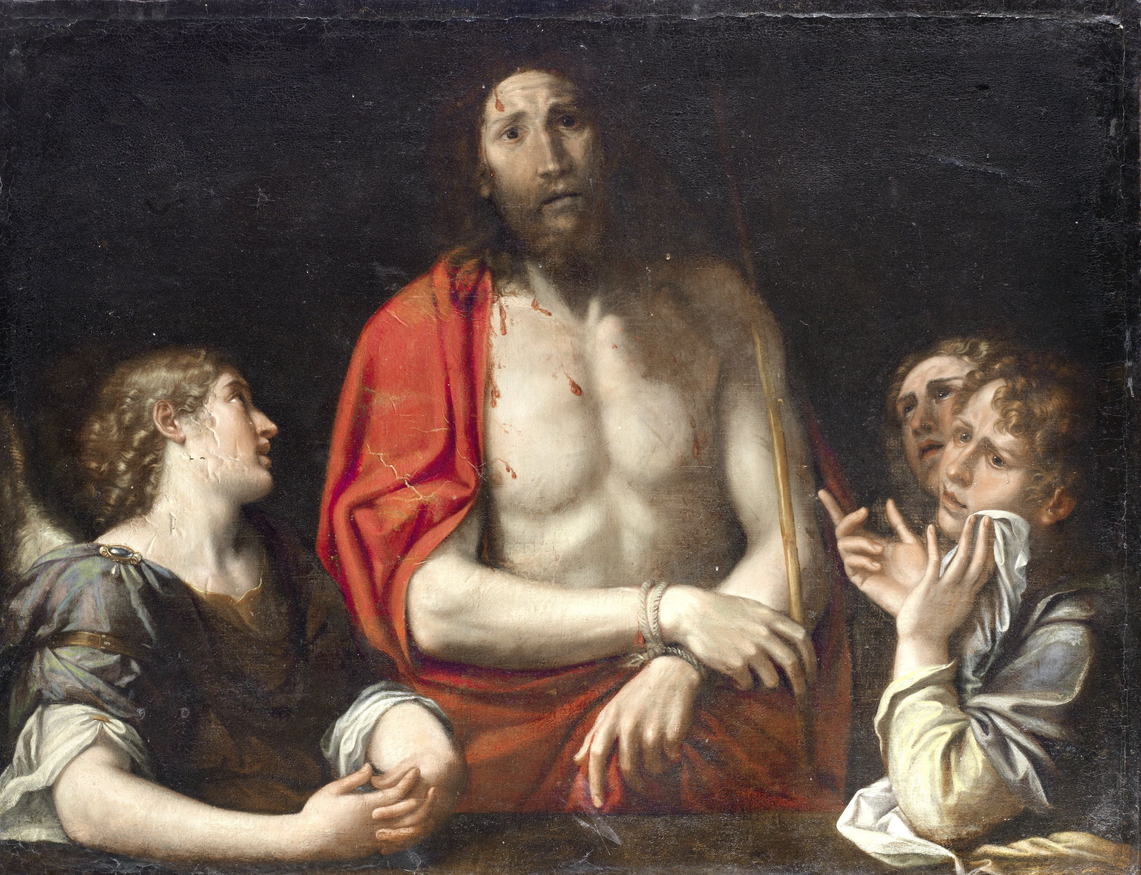
Photograph by kind permission of Bonhams, Fine Art Auctioneers & Valuers

